**Option 1: Register Student**

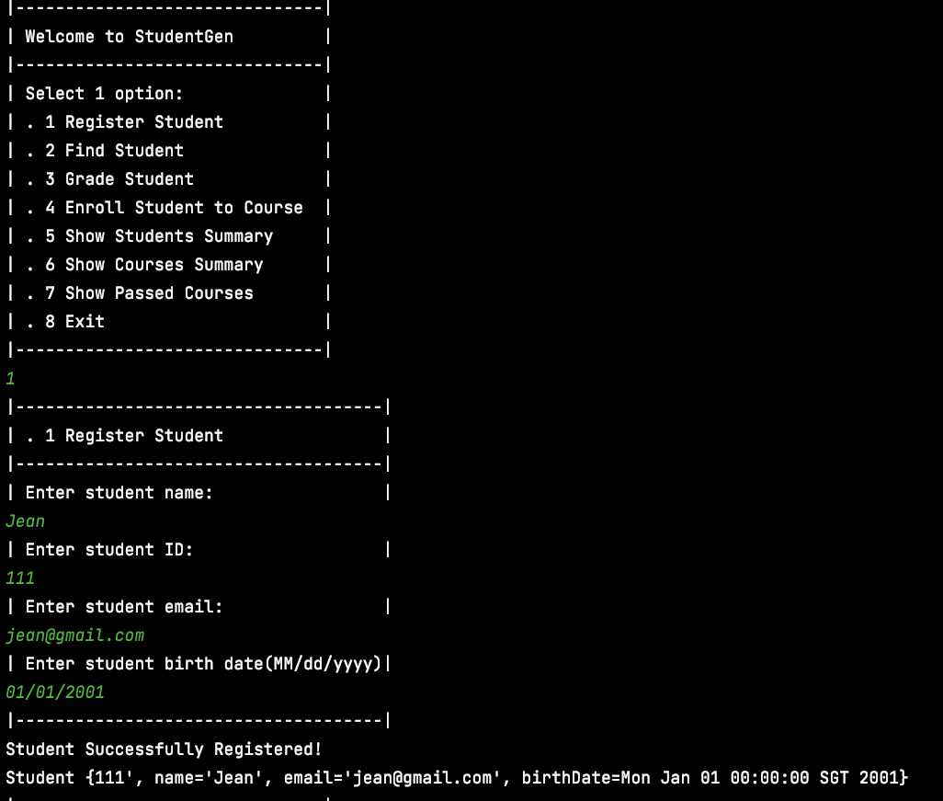

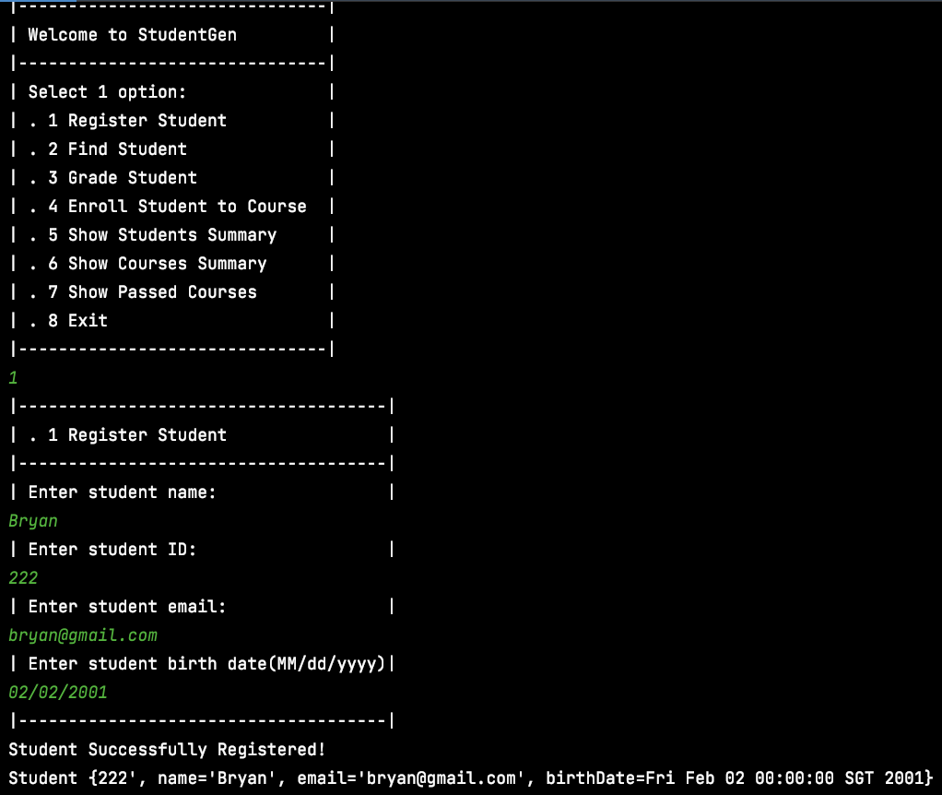

**Option 2: Find Student**

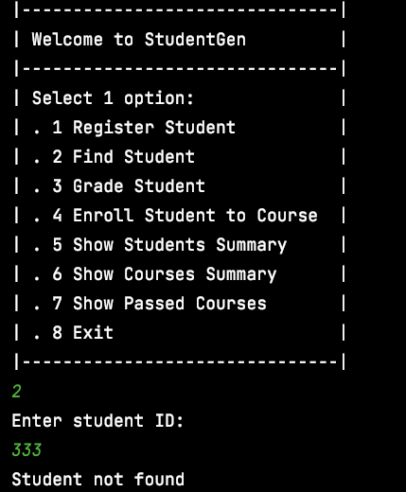

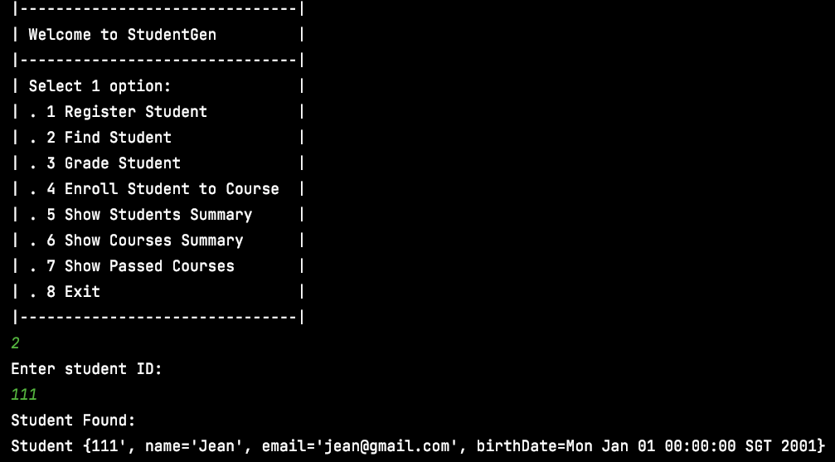

**Option 4: Enroll Student to Course**

(e.g. Student Id = 111, Course Ids = INTRO-CS-1 & INTRO-CS-2)

(e.g. Student Id = 222, Course Ids = INTRO-CS-2 & INTRO-CS-3)

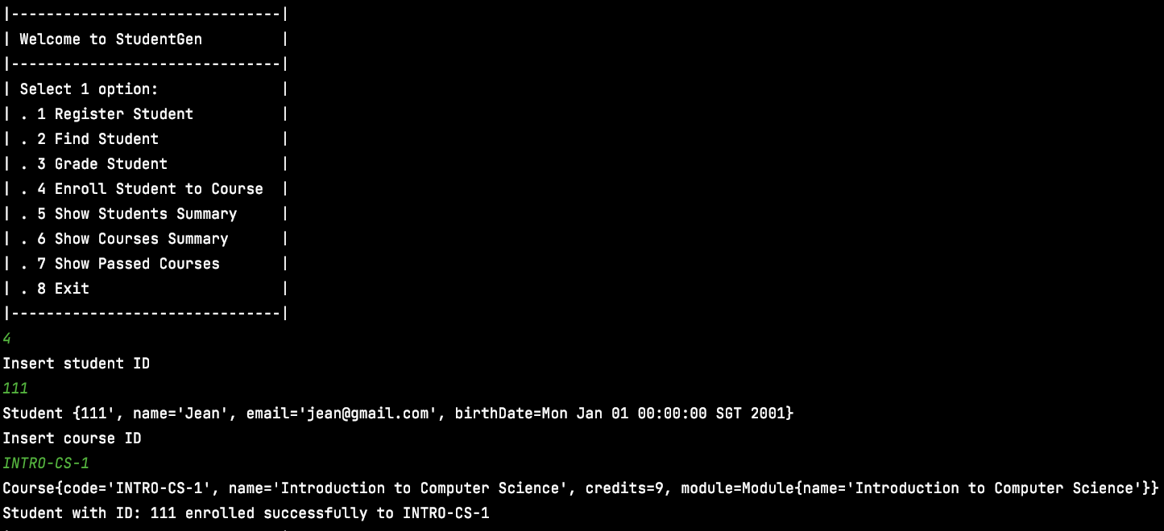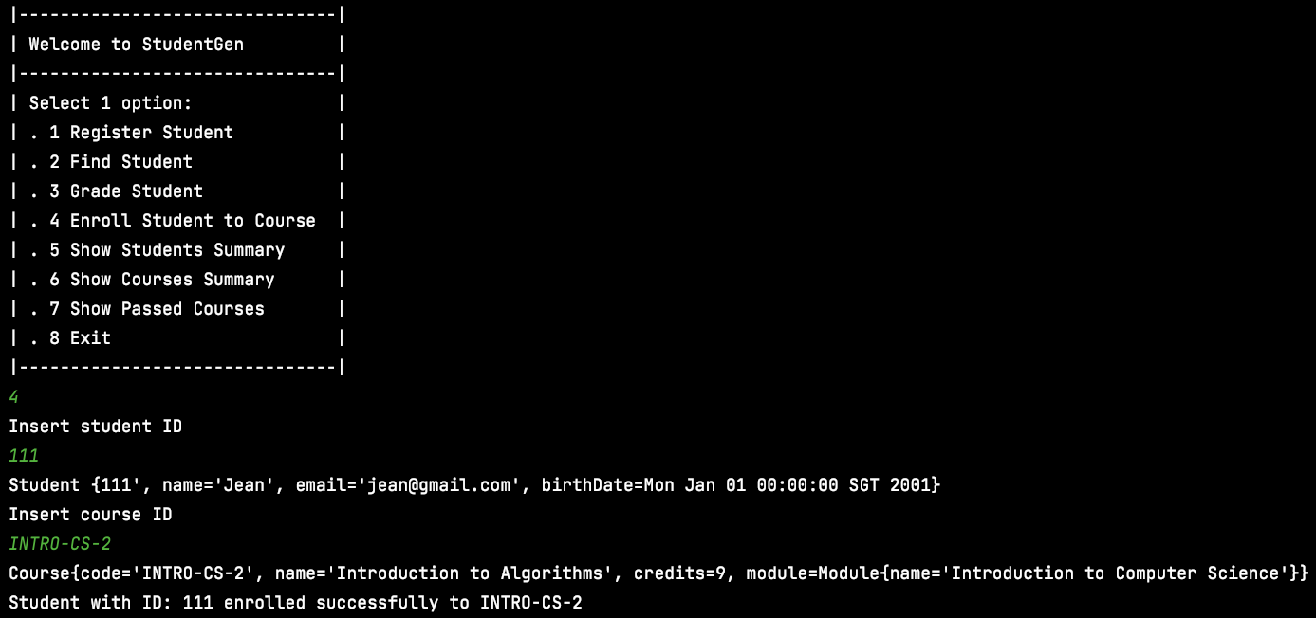

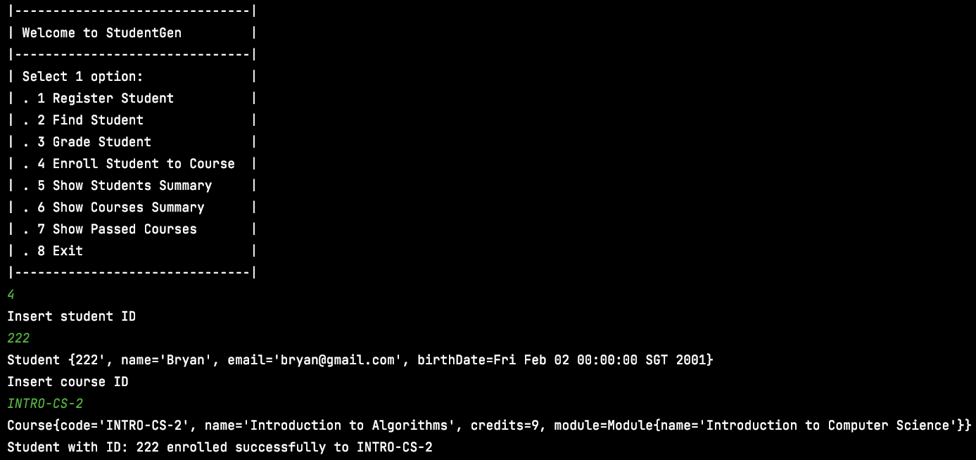

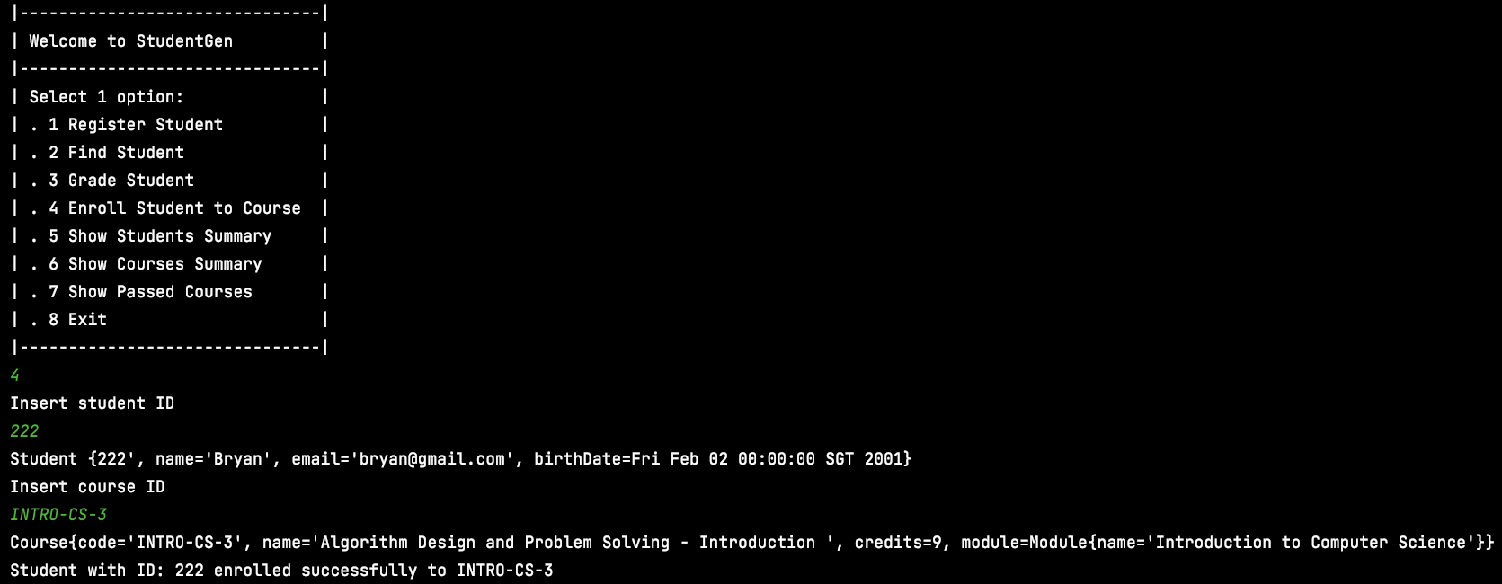

**Option 5: Show Students Summary**

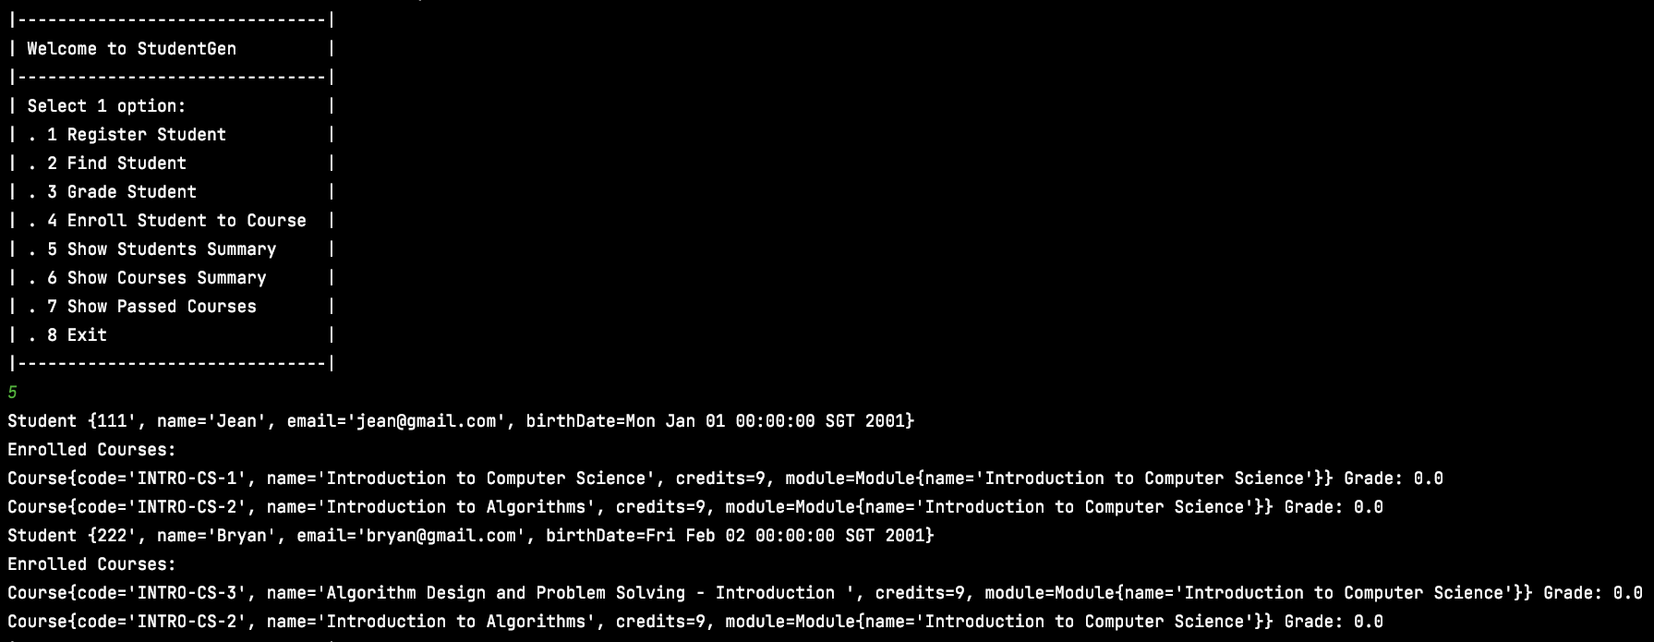

**Option 6: Show Courses Summary**

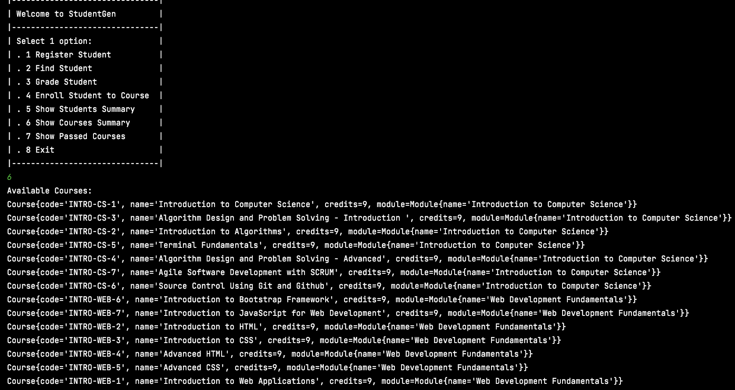

**Option 3: Grade Student**

(e.g. Student Id = 111, Course Ids = INTRO-CS-1 Grade = 2.5)

(e.g. Student Id = 111, Course Ids = INTRO-CS-2 Grade = 5.5)

(e.g. Student Id = 222, Course Ids = INTRO-CS-2 Grade = 3)

(e.g. Student Id = 222, Course Ids = INTRO-CS-3 Grade = 4.5)

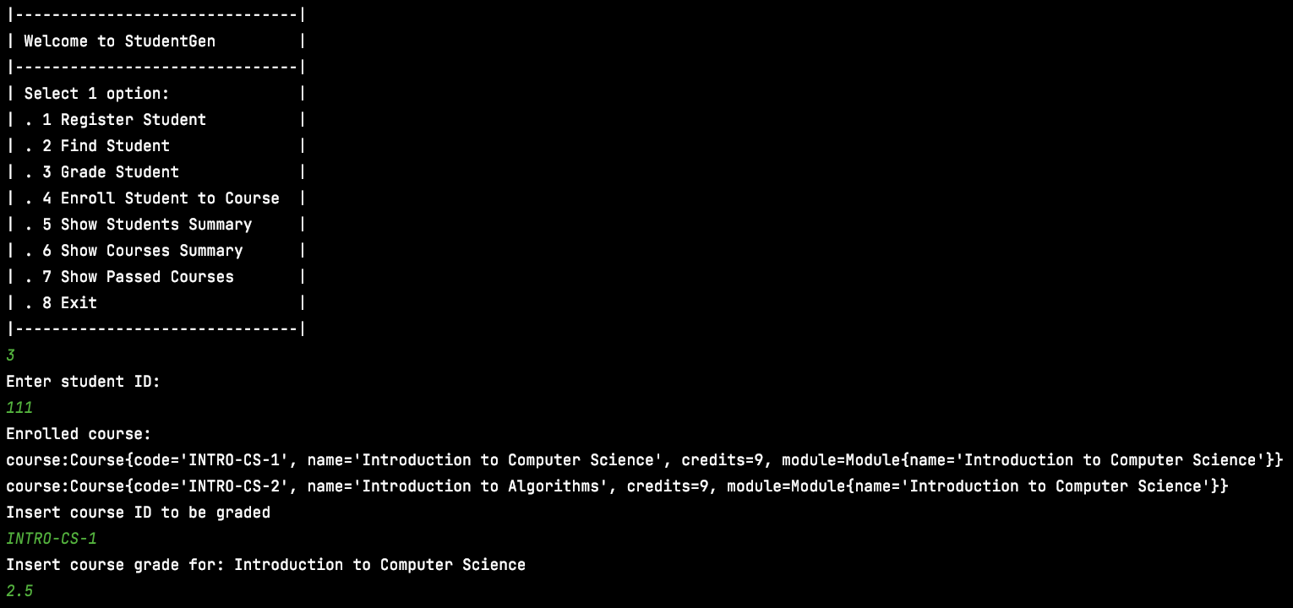

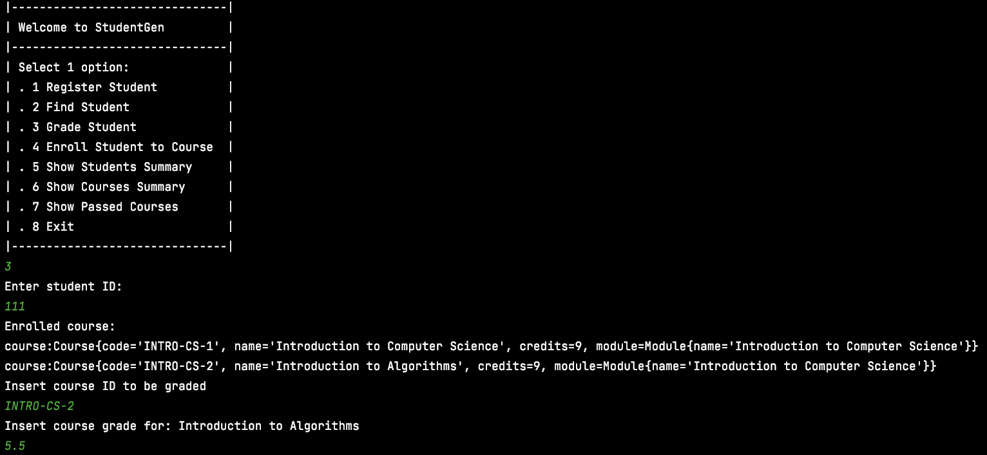

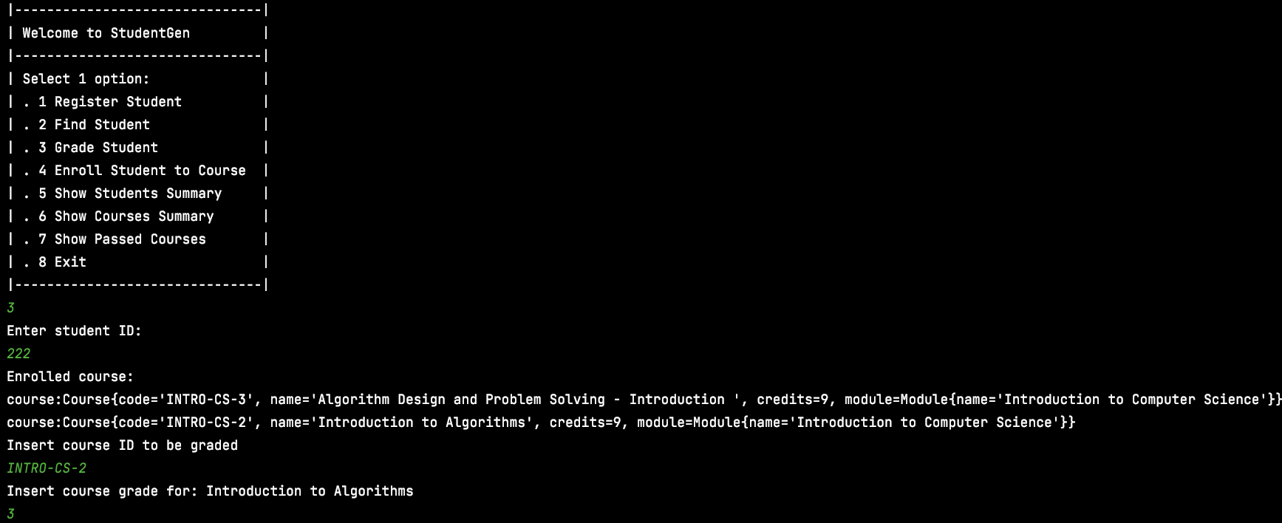

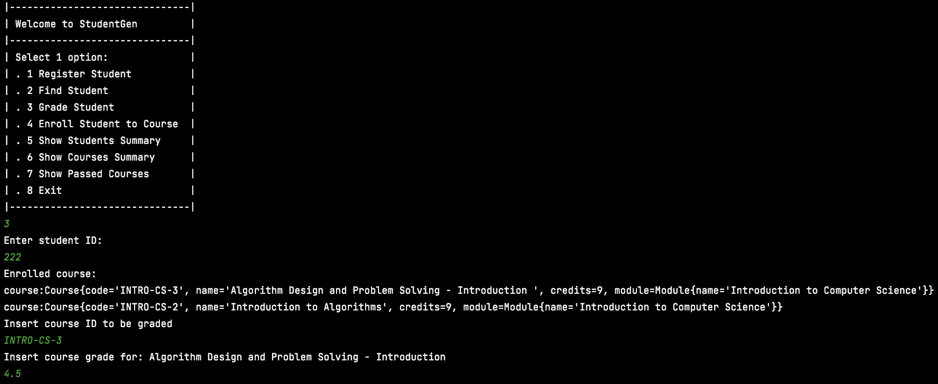

*Going back to Option 5 Show Students Summary will show the updated grades for the courses they are enrolled.*

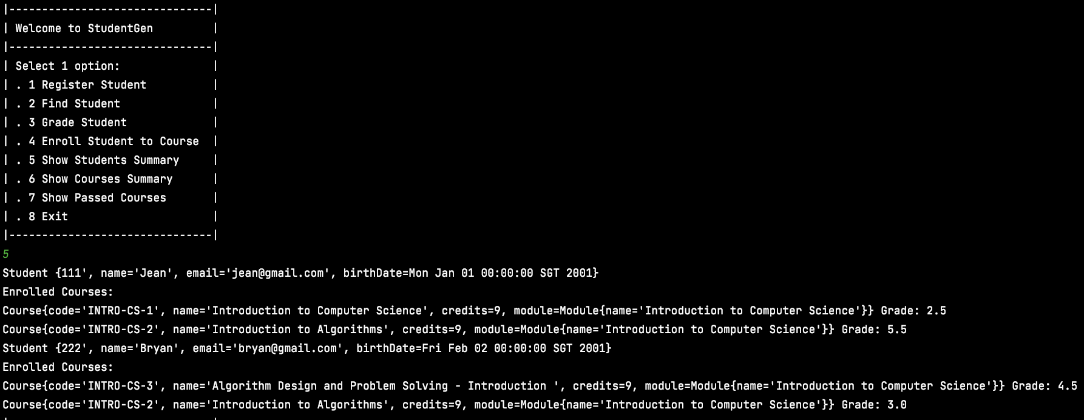

**Option 7: Show Passed Courses**

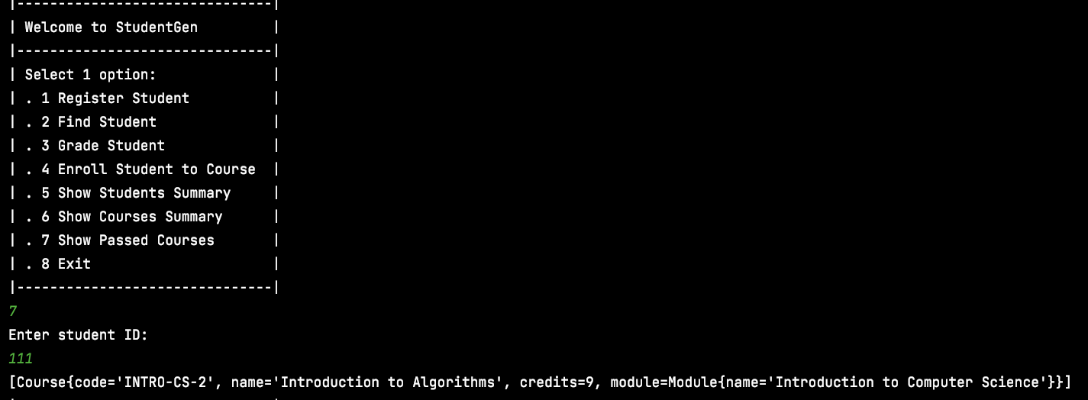

**Exception Handling for Date**

